P 🡪 Set of problems for which efficient algorithms exists.  
NP 🡪 Set of problems for which we do not know any sufficient algorithms.

The best algorithm that we know for these problems takes a huge amount of time.

**Approximation Algorithm** 🡪 I don’t want the best solution, but give me a solution which is closer to the best solution.  
One solution to the approximation problem doesn’t give a necessary solution to another approximation problem.  
One solution to the NP-hard problem doesn’t give a necessary solution to another NP-hard problems since they are similar to each-other..

**Hamiltonian Cycle** 🡪 Starts from a point. Visiting all the nodes exactly once and reaching the starting point again without re-visiting the nodes more than once.  
length of the cycle = Number of vertices

NP  
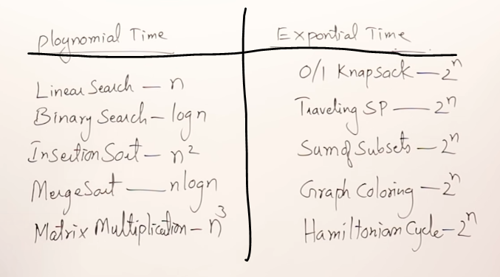

We want the exponential-time taking problems to be converted into polynomial-time taking algorithm.

Many research work are going on (i.e before 2010) , we want some-thing to be stored so that the future generations(i.e after 2010) can use these peoples (i.e before 2010) work and proceed further.

So some guidelines and frame-works must be there for the above research to take place and that frame-work 🡪 NP hard and NP complete

Part-1   
Writing non-deterministic polynomial time algorithm (i.e saving the research works)

Part-2

0/1 knapsack problem can be solved in polynomial time complexity (i.e representing in the form.

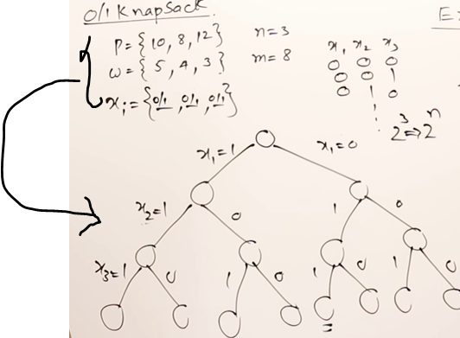

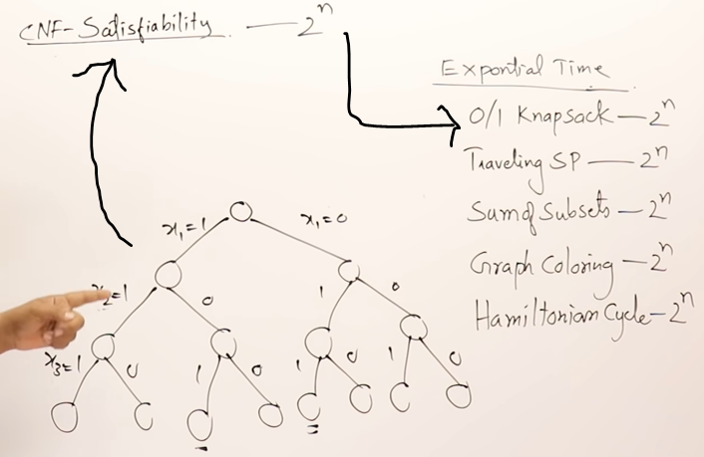

If I solve this state-space tree in polynomial time complexity, then the satisfiable problem will also be solved in polynomial time complexity.

There-fore we showed the relation-ships between the CNF satisfiable problem and these exponential-time problems.

So we linked the CNF-satisfiable problem with Exponential time taking problem.

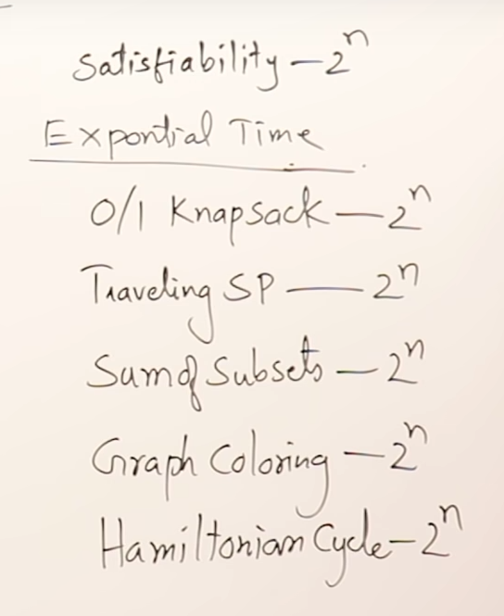

p will keep on growing-growing and in one fine day p=NP (i.e every thing that is not known I will be knowing)

Major problem  
Today I am writing non-deterministic and tomorrow it will become deterministic 🡪 Do you will it work ????

(Satisfiable becomes deterministic if p=NP)

References:  
<https://www.youtube.com/watch?v=hhEx2zNFPAk>

<https://www.youtube.com/watch?v=e2cF8a5aAhE&list=PLDN4rrl48XKpZkf03iYFl-O29szjTrs_O&index=72>